**MOBILE LAB REPORT**

**TASK 1**

**Introduction:**

Creating an Android Application to Sign Up with username, password, and email id. Registered user signing with username, password loads the username on the screen. User can also logout from the application when required.

**Features:**

* Sign Up
* Sign In
* Displaying Username
* Logout

**Objectives:**

User can sign up in to the application by entering username, password and email id. After successful sign up user will be prompted with a welcome message of his username. Logging out from application will prompt a message and then user gets logged out from the application.

**Approaches/Methods:**

Creating Activity files for App, Login, Logout and Sign Up.

Creating layout files for the above mentioned activity files.

Password validation is done through parser.

**Workflow:**

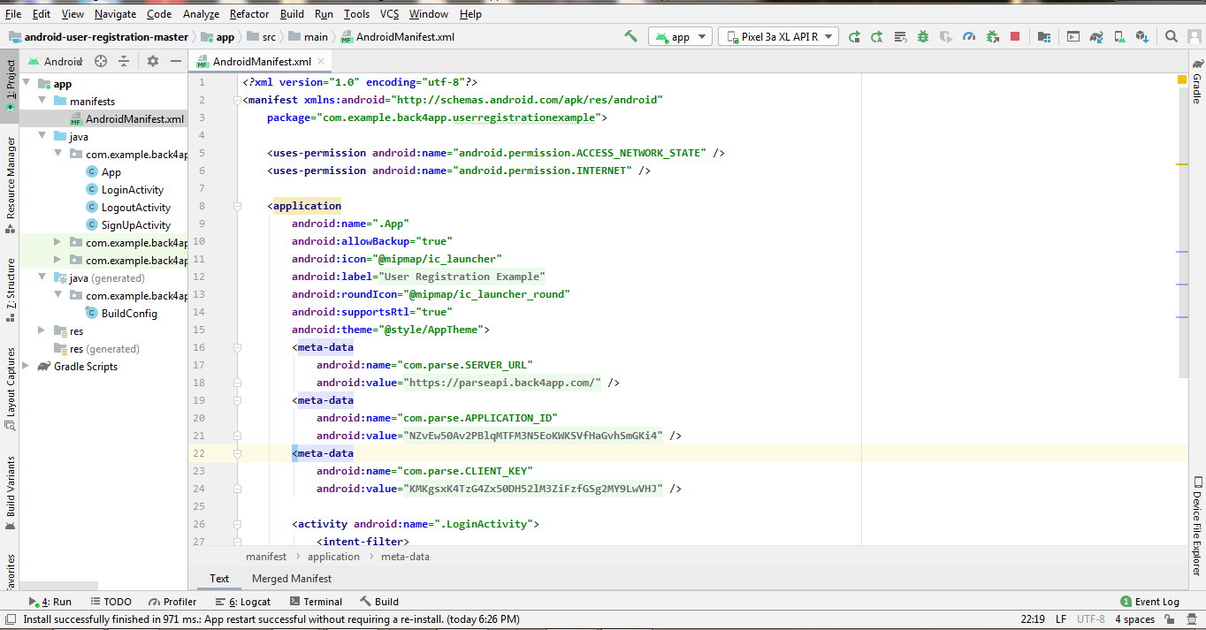

**AndroidManifest.xml File**

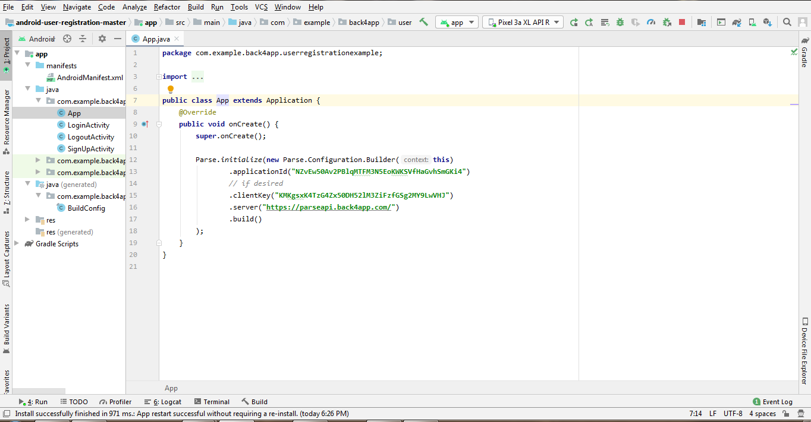

**App.java File**

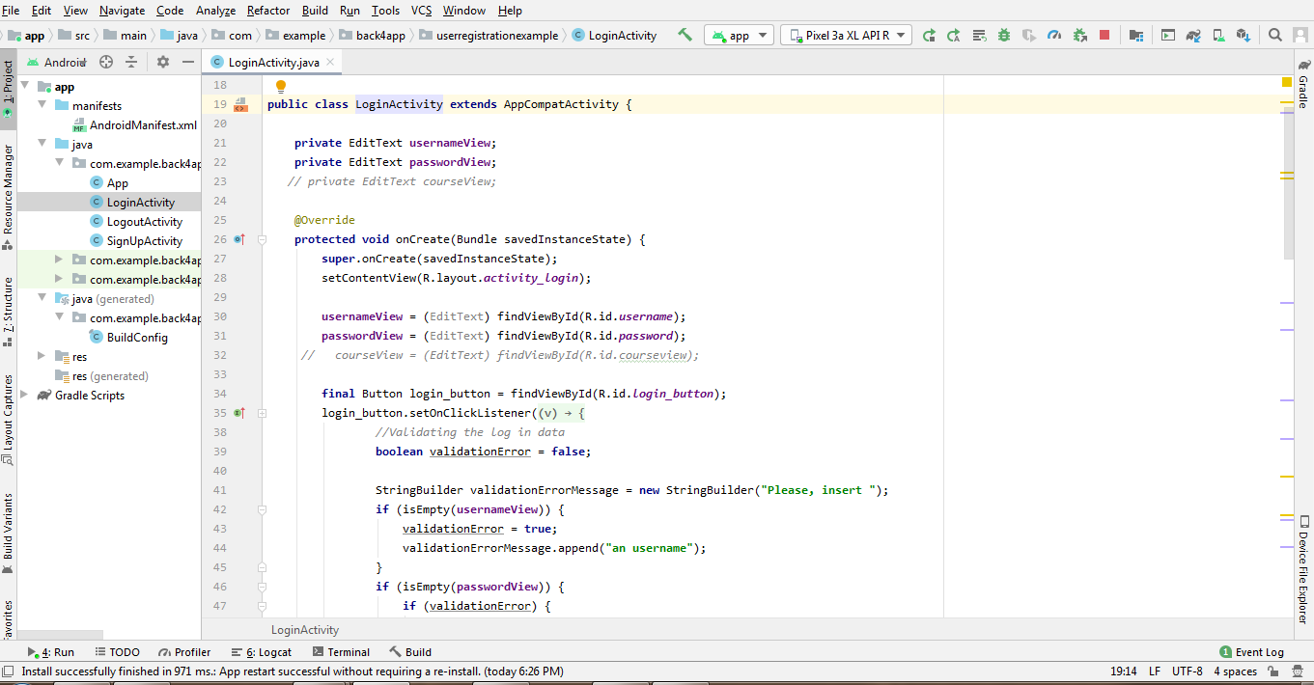

**LoginActivity.java File**

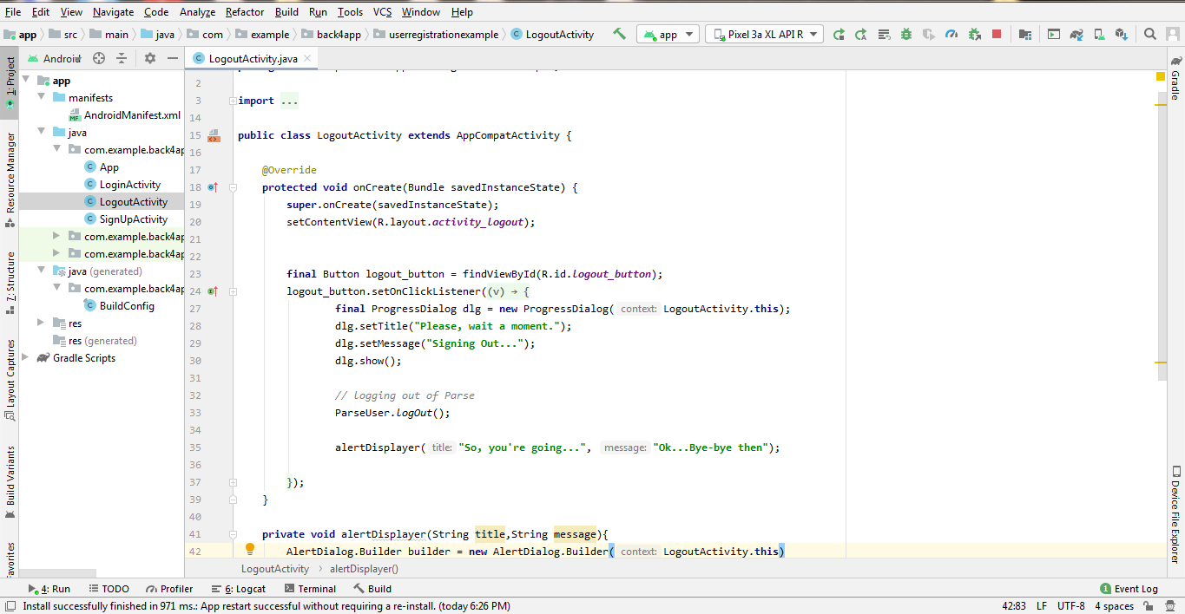

**LogoutActivity.java File**

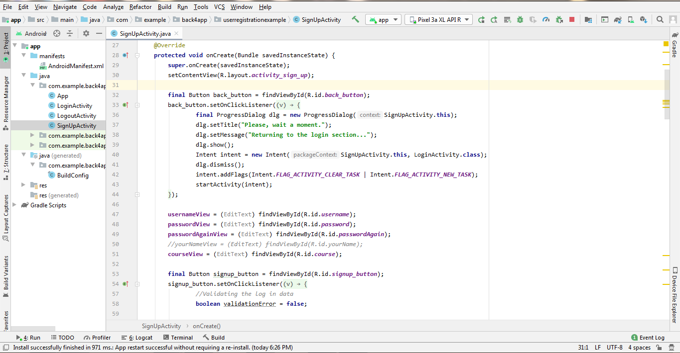

**SignUpActivity.java File**

**OUTPUT:**

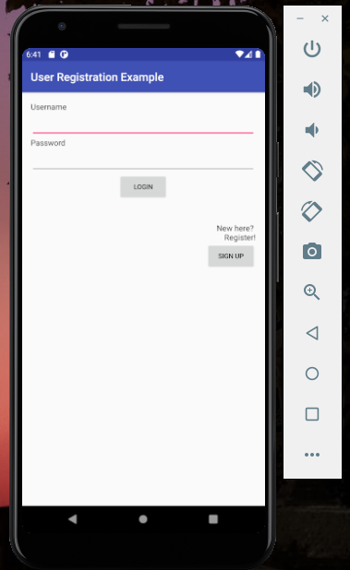

**Login Screen**

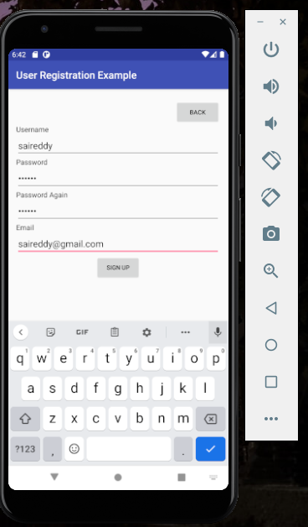

**Sign up Screen with User Details for User saireddy**

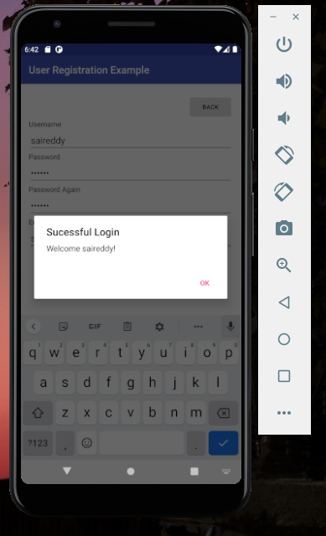

**Successful Login with displaying Username**

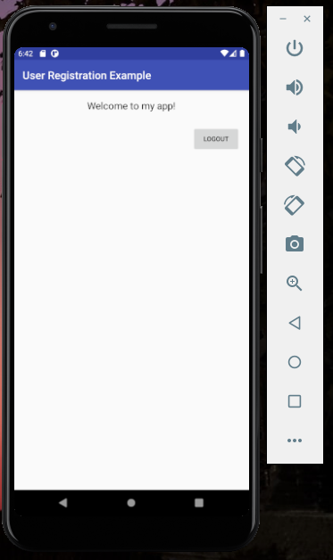

**My Application Screen**

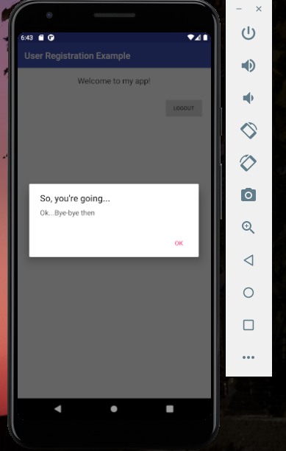

**When Logout button is pressed User will be prompted with an Alert.**

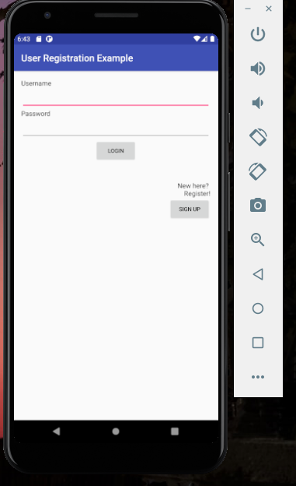

**User will be redirected to Login Page**

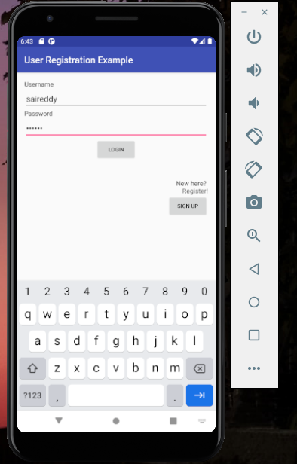

**Logging into the application with saireddy credentials**

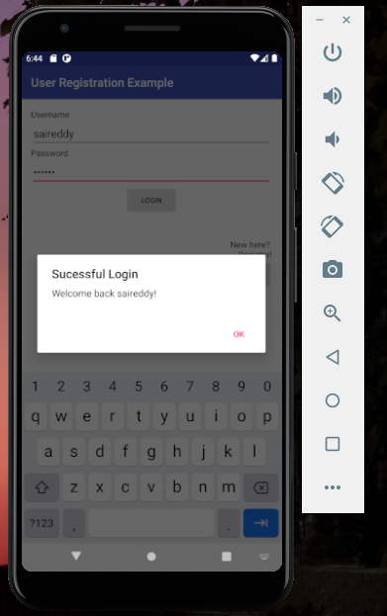

**Successful Login with Displaying Username**

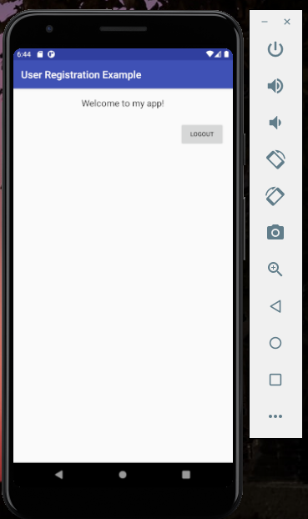

**My Application Screen**

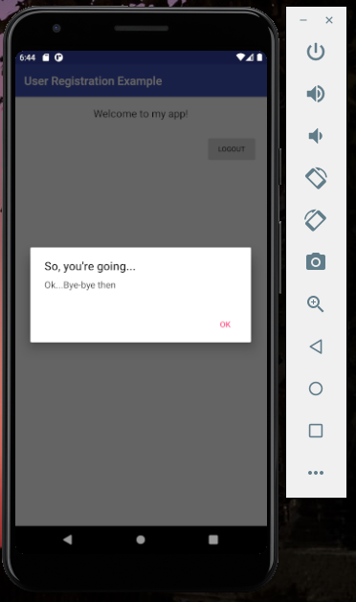

**When the User Clicks on Logout Button an alert will be prompted to User.**

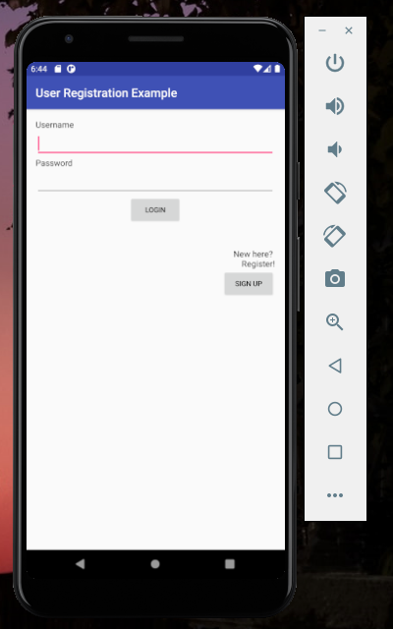

**Returning Back to Login Screen**

**Conclusion:**

An android application is created with features like Sign In, Sing Up, Displaying Username and Log Out. User can sign up with a username, password and an email id. Username gets displayed after successful login of the application. User can logout from the application when required.

**TASK 2**

**Introduction:**

Creating an Android Chat Application used to create friends on social media platform and send messages personally or in groups. Firebase have been used as the storage platform to store the data of users, messages, notifications, friend requests, and groups.

**Features:**

* Sign Up Using Email ID or Phone Number
* Sign In
* Adding and Username and Status
* Sending an Friend Request
* Accepting an Friend Request
* Creating a Group
* Sending Messages Personally or in a Group
* Logout

**Objectives:**

User have to Sign up using either Email ID or phone number. After sign up process, user gets redirected to a page where user should add a username and status to their profile. User can send requests to other users who are have been signed up in this application and user also accepts requests from other users. User can also create a group and send messages to other users personally or in a group. User can also able to view if any of his friends are in online or not. Logout functionality is available when user wants to logout from the application.

**Approaches/Methods**

Creating activity files for Chat, Chat Fragments, Contacts, Contact Fragments, Finding Friends, Group Chats, Messages, Message Adapters, Phone Login, Profile, Register, Requests Fragment, and Settings.

Creating the layout files for above mentioned activity files.

**Workflow:**

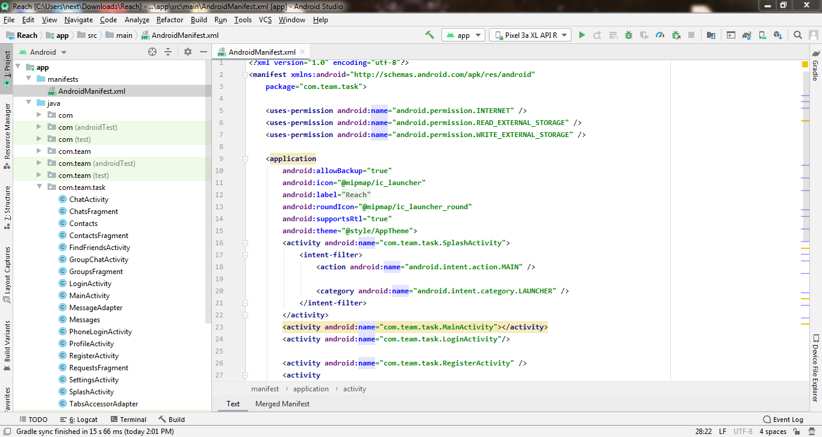

**AndroidManifest.XML File**

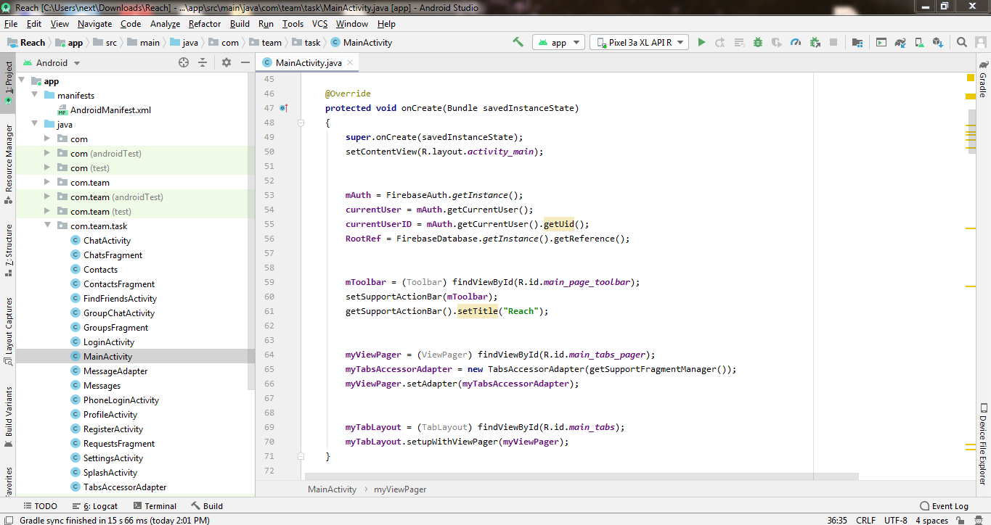

**MainActivity.java File**

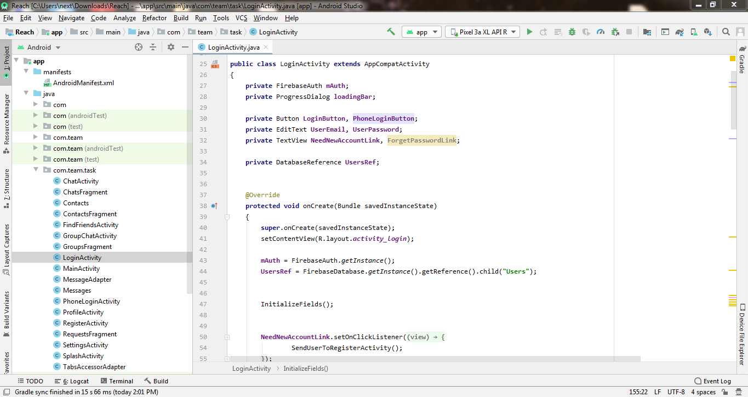

**LoginActivity.java File**

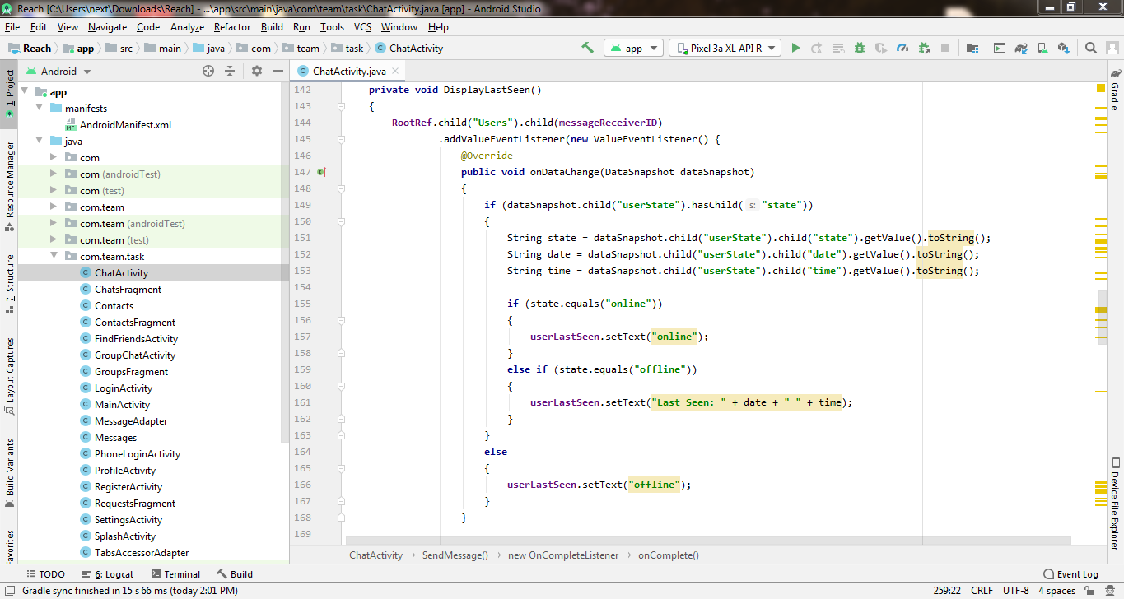

**ChatActivity.java File**

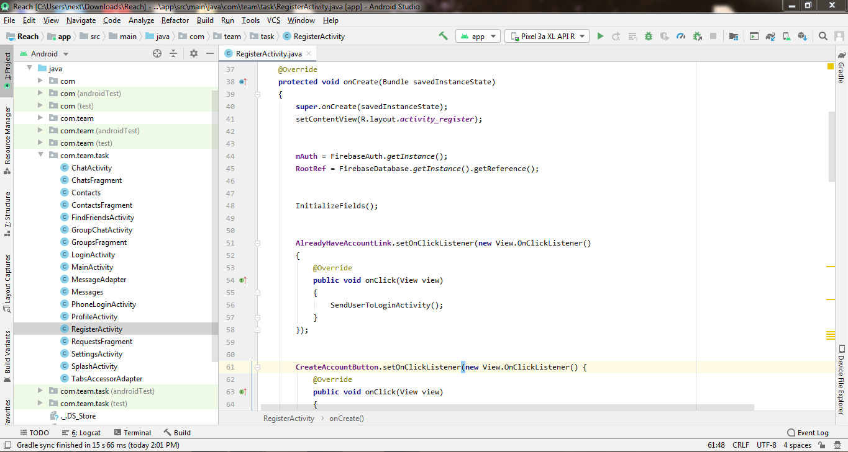

**RegisterActivity.java File**

**OUTPUT:**

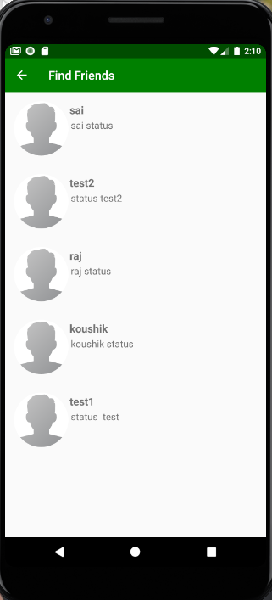

**Total No of Users Signed Up in the Application**

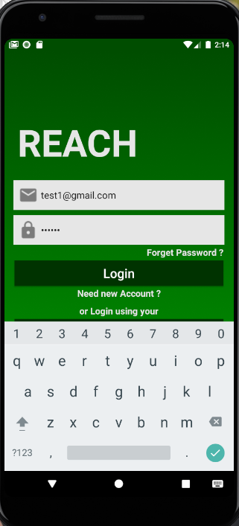

**Logging In with** [**test1@gmail.com**](mailto:test1@gmail.com) **Credentials**

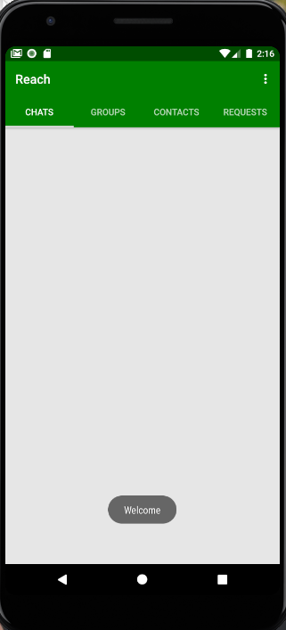

**Welcome screen after getting logged into the application**

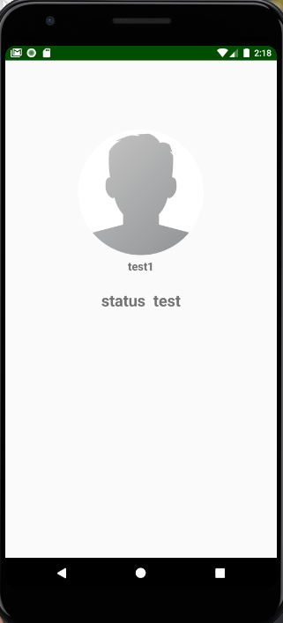

**User with Username and Status in the Profile Section**

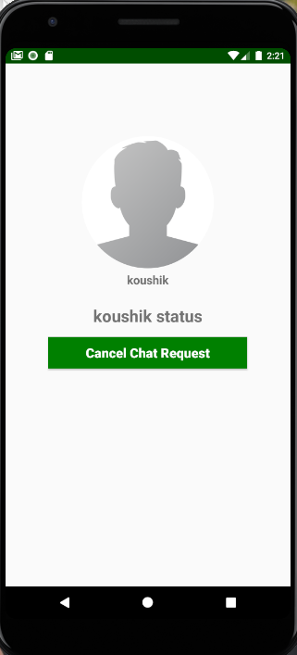

**Sending Requests to friends**

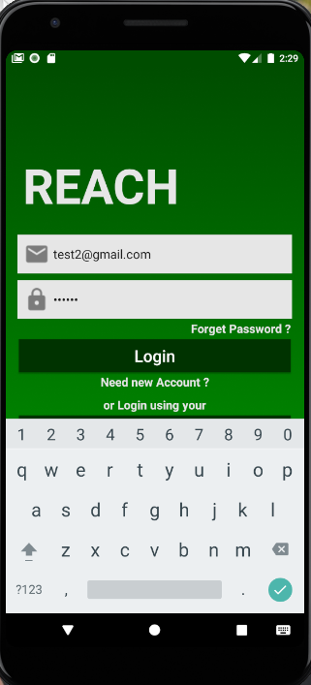

**Logging in with** [**test2@gmail.com**](mailto:test2@gmail.com) **credentials**

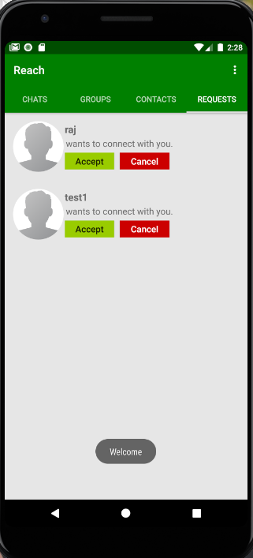

**Friend Requests Received to** [**test2@gmail.com**](mailto:test2@gmail.com)

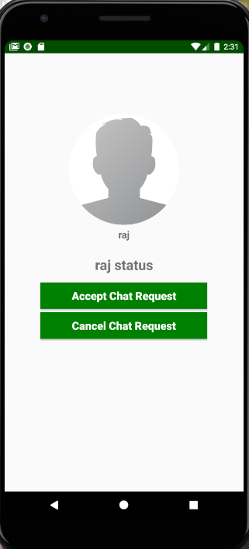

**Accepting Raj Request to Chat**

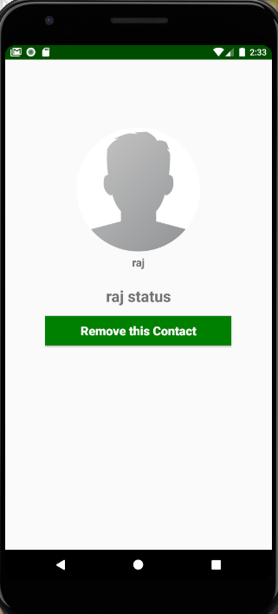

**Screen after accepting Raj Request to Chat**

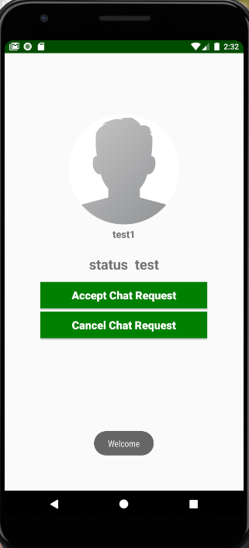

**Accepting Test1 User Chat Request**

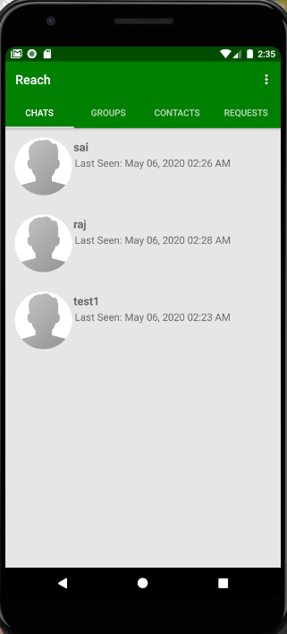

**Raj and User test1 can be found in User test2 Chats Window**

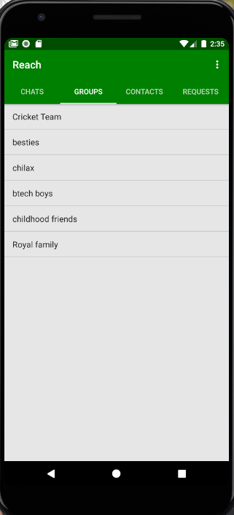

**Groups in User test2**

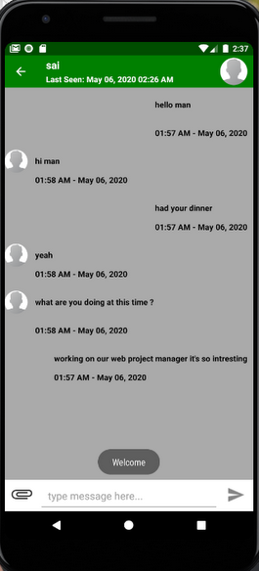

**Individual Chat with User Sai**

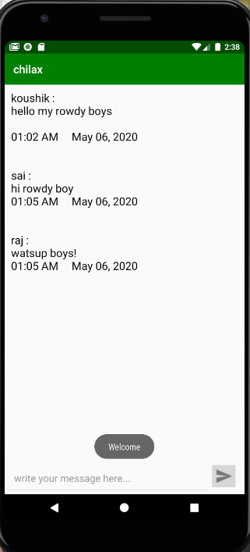

**Group Chat in the group named “chilax”**

**Firebase:**

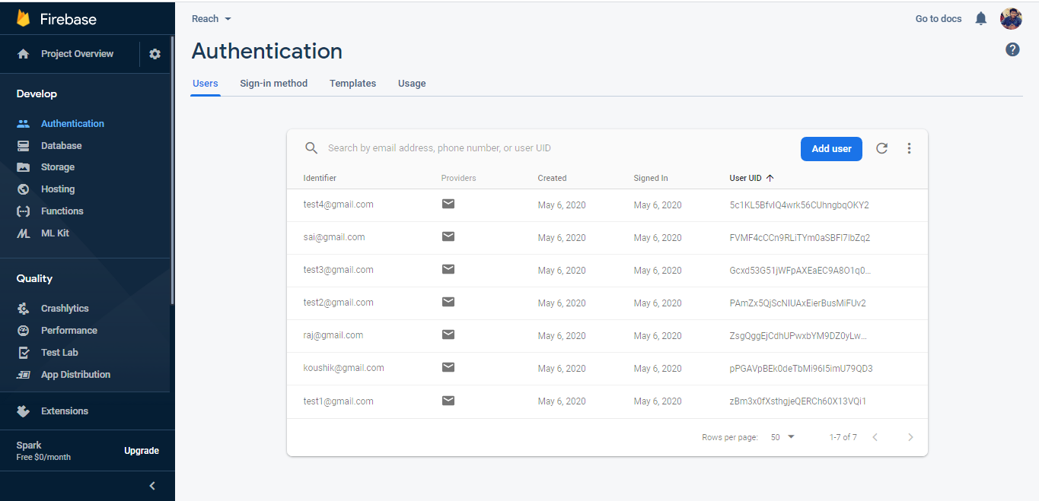

**Users in Authentication Console of Firebase**

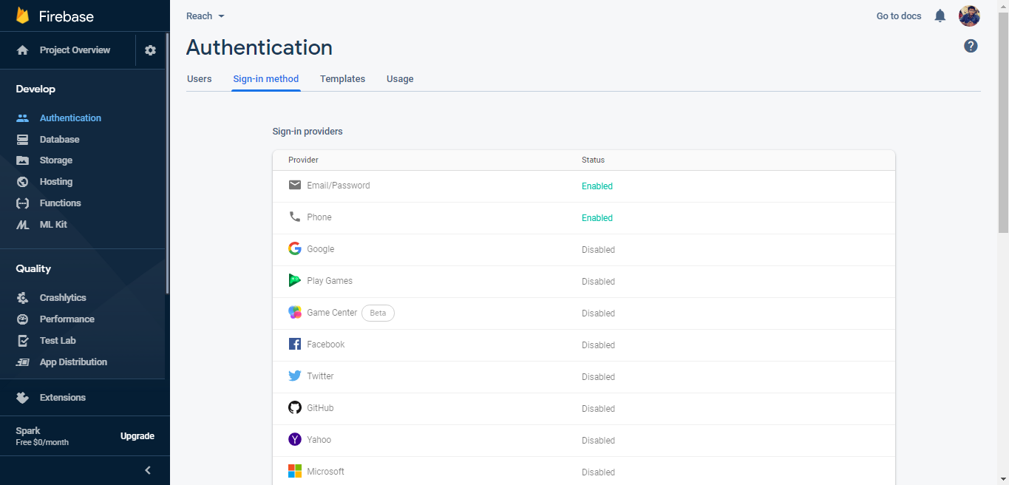

**Sign-in methods in Authentication Console of Firebase**

**Conclusion:**

An android chat application is created with features like sign up, sign in, sending requests, accepting requests, and sending messages personally and in groups and logging out from the application.